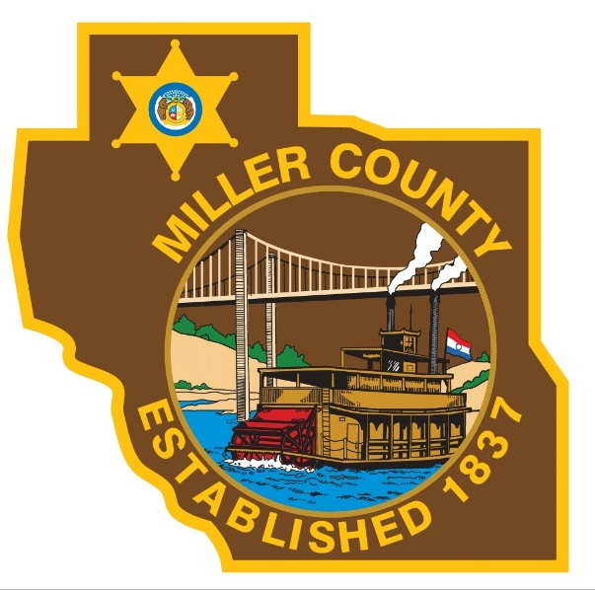
Sponsorship Form

Miller County Sheriff’s Office Annual
“Run with the cops, Not from the cops!”
5K/10K Run/Walk
April 14th, 2018
Eldon Air Park
Check in starts at 08:00 am
10K starts at 08:30 am, 5K starts at 09:00am

Sponsor Name:
_____________________________________________________________________________
Contact Name: _________________________________________________________________
Address: ______________________________________________________________________
Phone #: ______________________________________________________________________
Contact email: _________________________________________________________________

$100.00 – Name on T-shirt and Banner
$50.00 – Name on Banner (only)
Sponsorship level: ______________________________________________________________
* Proceeds will be used to help the Miller County Sheriff’s Office with Christmas with a Deputy (shop with a cop) program and other youth program in the community.
Amount received: _______________________________________________________________
Sheriff’s Office Contact: _________________________________________________________
Contact info: ___________________________________________________________________
All sponsors have the opportunity to contribute something to the runner’s gift bag.
Make checks payable to Miller County Youth Sports
For information, please contact Captain David Hannon at Miller County Sheriff’s Office
(573) 369-2341 ext. 720 or deputyhannon@millercountysheriff.com

